Supporting Information
Results - Biological measurements against developmental time
Mortality
Mortality was significantly correlated to developmental time in most cultures, except from two cultures (Table S8; p < 0.05). Mortality rates were low (< 5% day⁻¹) and similar at pH_{T} ≥ 6.90 (Fig. S1, linear regression, p = 0.77, n = 22). For the lowest pH cultures (pH_{T} ≤ 6.50), mortality was nearly two times higher than in the rest of the pHs.
Morphology
Growth rates of the four arms (POL, AL, PDL and PRL) were calculated from the significant linear relationship between the arm length and developmental time (Tables S9 A-D; p < 0.05) and plotted against mean pH_{T} (Fig. S2). The growth rates of arms were significantly lowered when pH_{T} was decreased (POL: p = 0.002, R² = 37 %, n = 24; AL: p = 0.001, R² = 41%, n = 23; PDL: p = 0.002, R² = 43%, n = 20), except from the PRL (p = 0.24, n = 9).
Both larval body width (BW) and paired arm tip distance (AG, POG, PDG) growth rates were calculated from the significant linear relationship between these measures and developmental time (Tables S10 A-D; p < 0.05). Neither BW, AG nor POG growth rates showed a significant relationship to mean pH_{T} (Fig. S3; p > 0.05, n = 24, 21 and 23 respectively). Although PDG displayed a significant relationship with mean pH_{T} (p < 0.01), this relation was considered biased since only four cultures had significant PDG growth rates (Tables S10 D).
Growth rates of the stomach volume were calculated from the significant linear relationship between the stomach volume (SV) and developmental time (Table S11; p < 0.05). This SV growth showed no significant relationship to mean pH_{T} (Fig. S4; p = 0.53, n = 24).
Respiration
Respiration rates were calculated from the significant linear relationship between the respiration and developmental time (Table S12; p < 0.05) and plotted against mean pH_{T} (Fig. S5). Respiration rates were not significantly correlated with pH_{T} (p = 0.41, n = 18).
Developmental stages
At days 1, 2, 3, 5, 7, 9, 11, 13,15 and 24, individuals were stages as gastrula (G) or pluteus (four to eight arms: P4, P6 and P8). The proportion of each stage was calculated for 6 pH categories (pH_{T} 8.0, 7.8. 7.6, 7.4, 7.2 and 7.0). The duration of G, P4 and P6 development stages (stage duration) was calculated as the difference of the median development time of two successive stages (the time when 50% of the organisms in a culture had passed that stage, which in turn was estimated from stage–frequency data converted to stage proportion). The stage duration for gastrula was 2.6±0.6 days with no effect of pH (Fig. S6) except for pH_{T}=7.0 with a stage duration of 4.5 days. Stage duration increased significantly with decreasing pH for both P4 (p<0.01) and P6 (p<0.01) stages (Fig. S6).
Supplementary Figures Captions:
Fig. S1: Relationship between larval mortality rate per developmental time (% larvae day⁻¹) and pH_{T}. Each dot represents the regression coefficient extracted from the significant linear relationship between mortality and time, for each culture (see regressions in Table S8).

Fig. S2: Relationship between arm (POL: postoral; AL: anterolateral; PDL: posterodorsal; PRL: preoral) growth rate per developmental time (μm day⁻¹) and pH_{T}. Each dot represents the regression coefficient extracted from the significant linear relationship between arm length and time, for each culture (see regressions in Tables S9A-D).

Fig. S3: Relationship between vertical gaps (BW: body width; POG: postoral arms gap; AG: anterolateral arms gap; PDG: postdorsal arm gap) growth rate per developmental time (μm day⁻¹) and pH_{T}. Each dot represents the regression coefficient extracted from the significant linear relationship between gap length and time, for each culture (see regressions in Tables S10A-D).

Fig. S4: Relationship between stomach volume (SV) growth rate per developmental time (μm³ day⁻¹) and pH_{T}. Each dot represents the regression coefficient extracted from the significant linear relationship between SV and time, for each culture (see regressions in Table S11).

Fig. S5: Relationship between respiration rate per developmental time (pmol O₂ h⁻¹ larva⁻¹ day⁻¹) and pH_{T}. Each dot represents the regression coefficient extracted from the significant linear relationship between respiration and time, for each culture (see regressions in Tables S12).

Fig. S6: Relationship between stage duration (day) for gastrula (G), pluteus-4 (P4) and pluteus-6 (P6) developmental stages and pH_{T} category.

Supplementary Figures:
Fig. S1:
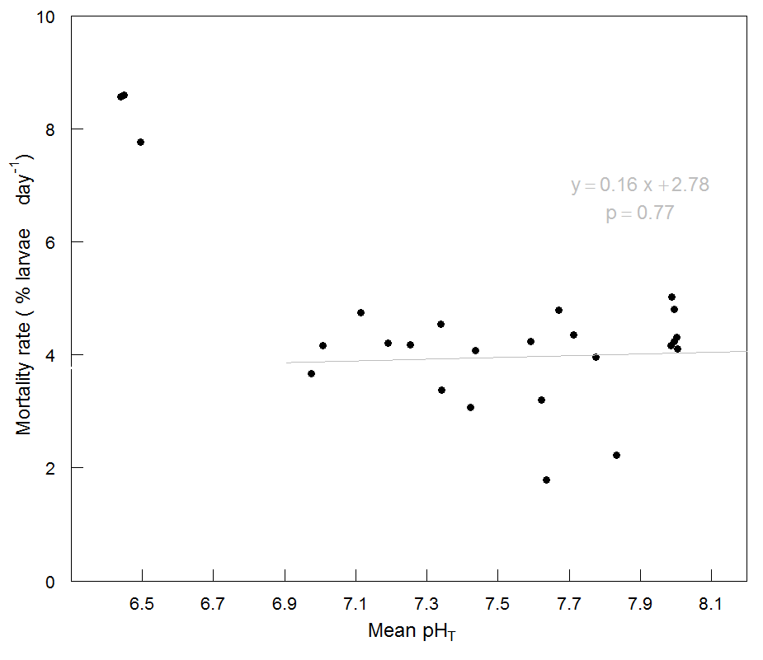
Fig. S2:
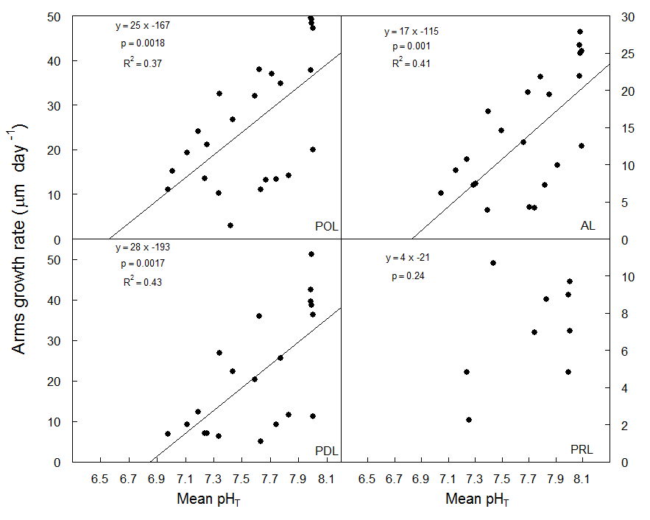

Fig. S3:
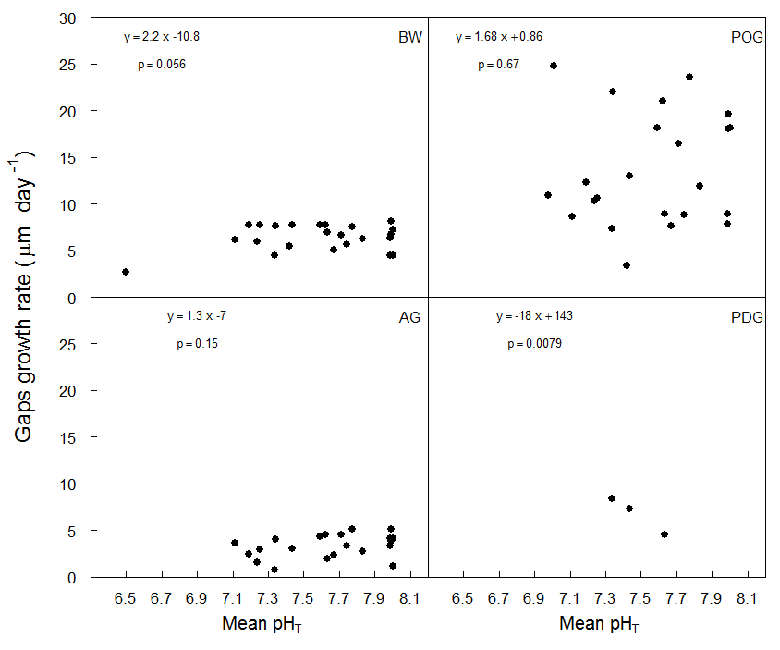
Fig. S4:
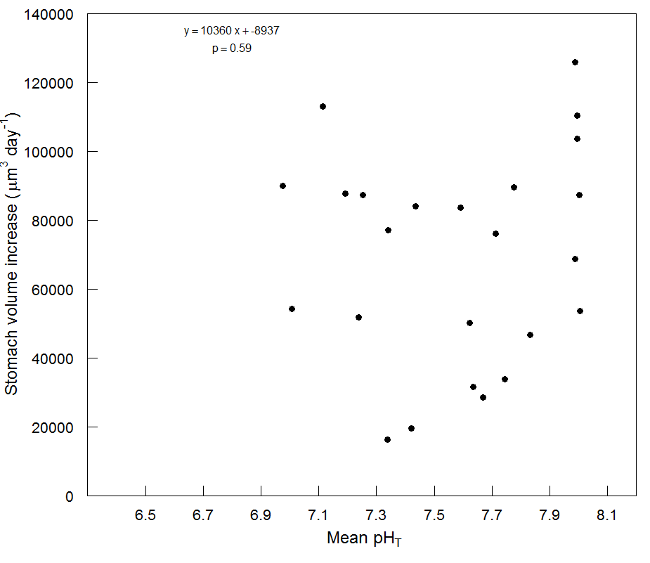
Fig. S5:
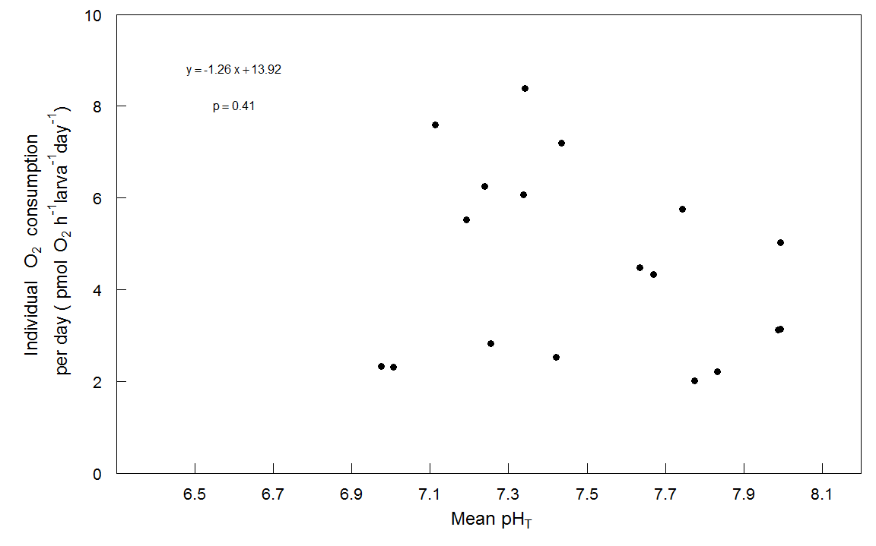

Fig. S6:
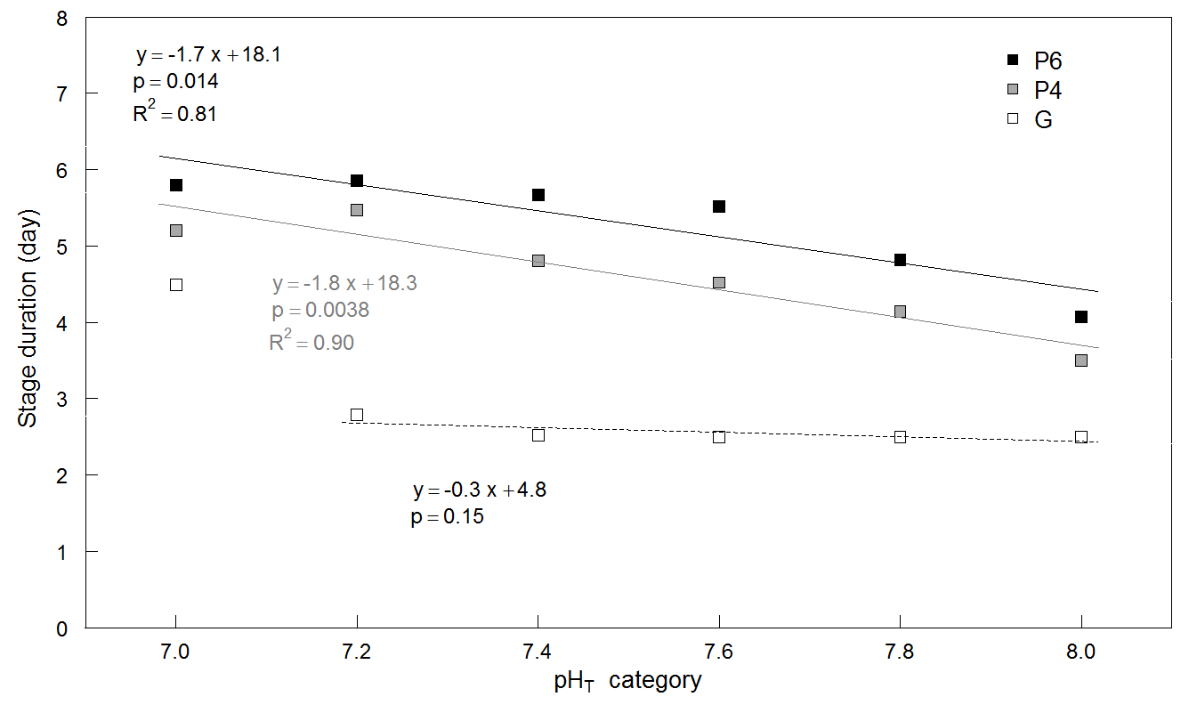

Supplementary Tables Captions:
Table S1: Larval growth rates (GR BL: μm day⁻¹) were calculated as the coefficient of the significant logarithmic relationship between BL and time. Results of the regressions (Intercept, p-value, R², F-value and df: degree of freedom) are given for each culture replicate (R) with corresponding average pH_{T} (pH_{T}). Data in bold (p-value>0.05) were removed from subsequent analyses.

Table S2: Larval mortality rate (% larvae μm_{BL}⁻¹) were calculated as the coefficient of the significant linear relationship between mortality and BL. Results of the regressions (Intercept, p-value, R², F-value and df: degree of freedom) are given for each culture replicate (R) with corresponding average pH_{T} (pH_{T}). Data in bold (p-value>0.05) were removed from subsequent analyses.

Table S3A-D: Larval arms growth rates (μm μm_{BL}⁻¹) of the four arm pairs (A. GR POL: postoral; B. GR AL: anterolateral; C. GR PDL: posterodorsal; D. GR PRL: preoral) were calculated as the coefficient of the significant linear relationship between the longest arm length and BL. Results of the regressions (Intercept, p-value, R², F-value and df: degree of freedom) are given for each culture replicate (R) with corresponding average pH_{T} (pH_{T}). Data in bold (p-value>0.05) were removed from subsequent analyses. Only replicates with enough data available (n>4) to perform a regression are presented.

Table S4A-D: Larval arms’ symmetry (no units) of the four arm pairs (A. Symmetry POL: postoral; B. Symmetry AL: anterolateral; C. Symmetry PDL: posterodorsal; D. Symmetry PRL: preoral) were calculated as the coefficient of the significant linear relationship between the longest and the shortest arm length of each pair, with null intercept. Results of the regressions (p-value, R², F-value and df: degree of freedom) are given for each culture replicate (R) with corresponding average pH_{T} (pH_{T}). Only replicates with enough data available (n>4) to perform a regression are presented.

Table S5A-D: Larval width (A. GR BW: body width) and gaps (B. GR POL: postoral; C. GR AL: anterolateral; D. GR PDL: posterodorsal) growth rates (μm μm_{BL}⁻¹) of the four arm pairs were calculated as the coefficient of the significant linear relationship between the length of each measure and BL. Results of the regressions (Intercept, p-value, R², F-value and df: degree of freedom) are given for each culture replicate (R) with corresponding average pH_{T} (pH_{T}). Data in bold (p-value>0.05) were removed from subsequent analyses. Only replicates with enough data available (n>4) to perform a regression are presented.

Table S6: Stomach volume growth rates (GR SV: μm³ μm_{BL}⁻¹) were calculated as the coefficient of the significant linear relationship between the stomach volume and BL. Results of the regressions (Intercept, p-value, R², F-value and df: degree of freedom) are given for each culture replicate (R) with corresponding average pH_{T} (pH_{T}). Data in bold (p-value>0.05) were removed from subsequent analyses. Only replicates with enough data available (n>4) to perform a regression are presented.

Table S7: Respiration rates (pmol O₂ h⁻¹ larvae⁻¹ μm_{BL}⁻¹) were calculated as the coefficient of the significant linear relationship between the respiration and BL. Results of the regressions (Intercept, p-value, R², F-value and df: degree of freedom) are given for each culture replicate (R) with corresponding average pH_{T} (pH_{T}). Data in bold (p-value>0.05) were removed from subsequent analyses. Only replicates with enough data available (n>4) to perform a regression are presented.

Table S8: Larval mortality rate (% larvae day⁻¹) were calculated as the coefficient of the significant linear relationship between mortality and time. Results of the regressions (Intercept, p-value, R², F-value and df: degree of freedom) are given for each culture replicate (R) with corresponding average pH_{T} (pH_{T}). Data in bold (p-value>0.05) were removed from subsequent analyses.

Tables S9A-D: Larval arms growth rates (μm day⁻¹) of the four arm pairs (A. GR POL: postoral; B. GR AL: anterolateral; C. GR PDL: posterodorsal; D. GR PRL: preoral) were calculated as the coefficient of the significant linear relationship between the longest arm length and time. Results of the regressions (Intercept, p-value, R², F-value and df: degree of freedom) are given for each culture replicate (R) with corresponding average pH_{T} (pH_{T}). Data in bold (p-value>0.05) were removed from subsequent analyses. Only replicates with enough data available (n>4) to perform a regression are presented.

Table S10A-D: Larval width (A. GR BW: body width) and gaps (B. GR POL: postoral; C. GR AL: anterolateral; D. GR PDL: posterodorsal) growth rates (μm day⁻¹) of the four arm pairs were calculated as the coefficient of the significant linear relationship between the length of each measure and time. Results of the regressions (Intercept, p-value, R², F-value and df: degree of freedom) are given for each culture replicate (R) with corresponding average pH_{T} (pH_{T}). Data in bold (p-value>0.05) were removed from subsequent analyses. Only replicates with enough data available (n>4) to perform a regression are presented.

Table S11: Stomach volume growth rates (GR SV: μm³ day⁻¹) were calculated as the coefficient of the significant linear relationship between the stomach volume and time. Results of the regressions (Intercept, p-value, R², F-value and df: degree of freedom) are given for each culture replicate (R) with corresponding average pH_{T} (pH_{T}). Only replicates with enough data available (n>4) to perform a regression are presented.

Table S12: Respiration rates (pmol O₂ h⁻¹ larvae⁻¹ day⁻¹) were calculated as the coefficient of the significant linear relationship between the respiration and time. Results of the regressions (Intercept, p-value, R², F-value and df: degree of freedom) are given for each culture replicate (R) with corresponding average pH_{T} (pH_{T}). Data in bold (p-value>0.05) were removed from subsequent analyses. Only replicates with enough data available (n>4) to perform a regression are presented.
Supplementary Tables:
Table S1
R | pH_{T} | GR BL | Intercept | p-value | R² | F-value | df
6.5a | 6.44 | -5.5 | 164 | 3.1E-01 | 0.04 | 1.6 | 43
6.5b | 6.50 | 7.1 | 156 | 4.7E-02 | 0.09 | 4.5 | 48
6.5c | 6.45 | -3.5 | 159 | 4.0E-01 | 0.02 | 1.0 | 44
7.1a | 6.98 | 39 | 162 | 2.2E-14 | 0.47 | 85 | 94
7.1b | 7.01 | 38 | 164 | 1.2E-13 | 0.52 | 92 | 84
7.1c | 7.11 | 73 | 149 | 4.8E-35 | 0.87 | 582 | 90
7.3a | 7.25 | 84 | 148 | 1.6E-40 | 0.90 | 836 | 98
7.3b | 7.19 | 83 | 144 | 7.6E-41 | 0.92 | 982 | 88
7.3c | 7.24 | 72 | 146 | 4.0E-39 | 0.87 | 675 | 104
7.5a | 7.42 | 66 | 171 | 2.0E-30 | 0.77 | 347 | 104
7.5b | 7.34 | 69 | 165 | 1.3E-35 | 0.87 | 563 | 88
7.5c | 7.44 | 95 | 139 | 2.5E-44 | 0.94 | 1396 | 96
7.7a | 7.34 | 89 | 149 | 2.3E-45 | 0.93 | 1065 | 86
7.7b | 7.64 | 94 | 147 | 4.4E-39 | 0.88 | 743 | 102
7.7c | 7.67 | 84 | 159 | 1.2E-40 | 0.88 | 683 | 96
7.7e | 7.62 | 92 | 147 | 4.1E-43 | 0.91 | 899 | 89
7.7f | 7.59 | 93 | 148 | 9.8E-41 | 0.91 | 821 | 86
7.7g | 7.71 | 87 | 159 | 2.2E-35 | 0.89 | 666 | 80
7.9a | 7.78 | 96 | 150 | 2.7E-50 | 0.94 | 1373 | 90
7.9b | 7.74 | 88 | 158 | 7.4E-52 | 0.92 | 1184 | 98
7.9c | 7.83 | 85 | 166 | 2.5E-47 | 0.88 | 798 | 106
8.1a | 7.99 | 101 | 148 | 5.8E-38 | 0.91 | 864 | 81
8.1b | 7.99 | 94 | 158 | 5.2E-34 | 0.91 | 678 | 71
8.1c | 7.99 | 103 | 146 | 3.4E-48 | 0.95 | 1516 | 87
8.1e | 7.99 | 93 | 158 | 1.9E-44 | 0.93 | 1111 | 85
8.1f | 8.00 | 100 | 152 | 7.5E-53 | 0.95 | 1658 | 92
8.1g | 8.00 | 91 | 159 | 6.6E-54 | 0.93 | 1300 | 99

TableS2
R | pH_{T} | Mortality  rates | Intercept | p-value | R² | F-value | df
6.5a | 6.44 | -18.4 | 2903 | 6.7E-06 | 0.91 | 85.8 | 9
6.5b | 6.50 | 11.6 | -1922 | 1.8E-03 | 0.68 | 19.2 | 9
6.5c | 6.45 | -28.7 | 4447 | 7.3E-04 | 0.74 | 25.1 | 9
7.1a | 6.98 | 0.85 | -247 | 3.6E-11 | 0.91 | 181.7 | 19
7.1b | 7.01 | 0.99 | -280 | 1.1E-09 | 0.86 | 120.9 | 19
7.1c | 7.11 | 0.51 | -207 | 3.9E-06 | 0.68 | 40.9 | 19
7.3a | 7.25 | 0.36 | -178 | 4.7E-05 | 0.59 | 27.4 | 19
7.3b | 7.19 | 0.36 | -171 | 2.0E-04 | 0.53 | 21.1 | 19
7.3c | 7.24 | 0.10 | -94 | 1.6E-01 | 0.10 | 2.17 | 19
7.5a | 7.42 | 0.33 | -164 | 7.1E-04 | 0.46 | 16.3 | 19
7.5b | 7.34 | 0.54 | -214 | 6.9E-06 | 0.66 | 37.5 | 19
7.5c | 7.44 | 0.33 | -162 | 2.2E-05 | 0.62 | 31.3 | 19
7.7a | 7.34 | 0.23 | -138 | 8.6E-03 | 0.31 | 8.59 | 19
7.7b | 7.64 | 0.14 | -118 | 2.5E-03 | 0.39 | 12.1 | 19
7.7c | 7.67 | 0.41 | -199 | 1.2E-04 | 0.55 | 23.2 | 19
7.7e | 7.62 | 0.22 | -147 | 6.0E-03 | 0.34 | 9.57 | 19
7.7f | 7.59 | 0.36 | -181 | 8.2E-06 | 0.66 | 36.5 | 19
7.7g | 7.71 | 0.38 | -177 | 6.2E-05 | 0.58 | 26.1 | 19
7.9a | 7.78 | 0.29 | -162 | 2.2E-04 | 0.52 | 20.8 | 19
7.9b | 7.74 | -0.01 | -53 | 8.7E-01 | 0.001 | 0.03 | 19
7.9c | 7.83 | 0.15 | -120 | 1.8E-02 | 0.26 | 6.70 | 19
8.1a | 7.99 | 0.36 | -186 | 9.3E-06 | 0.65 | 35.8 | 19
8.1b | 7.99 | 0.43 | -202 | 1.2E-05 | 0.64 | 34.3 | 19
8.1c | 7.99 | 0.31 | -162 | 4.1E-05 | 0.60 | 28.1 | 19
8.1e | 7.99 | 0.36 | -169 | 8.5E-06 | 0.66 | 36.3 | 19
8.1f | 8.00 | 0.32 | -167 | 7.4E-05 | 0.57 | 25.3 | 19
8.1g | 8.00 | 0.34 | -170 | 2.8E-05 | 0.61 | 29.9 | 19

Table S3A
R | pH_{T} | GR POL | Intercept | p-value | R² | F-value | df
7.1a | 6.98 | 1.3 | -42 | 2.4E-12 | 0.65 | 88.12 | 47
7.1b | 7.01 | 0.9 | 39 | 1.3E-07 | 0.53 | 42.37 | 37
7.1c | 7.11 | 1.7 | -149 | 1.1E-14 | 0.65 | 106.8 | 57
7.3a | 7.25 | 1.9 | -232 | 1.3E-20 | 0.73 | 179.4 | 67
7.3b | 7.19 | 2.0 | -257 | 2.2E-21 | 0.80 | 223.8 | 57
7.3c | 7.24 | 1.8 | -189 | 1.8E-16 | 0.66 | 123.3 | 63
7.5a | 7.42 | 1.2 | -20 | 3.6E-11 | 0.45 | 60.61 | 73
7.5b | 7.34 | 1.6 | -122 | 1.2E-14 | 0.63 | 102.3 | 61
7.5c | 7.44 | 2.0 | -226 | 1.7E-19 | 0.72 | 166.9 | 64
7.7a | 7.34 | 2.6 | -444 | 2.2E-16 | 0.70 | 132.4 | 56
7.7b | 7.64 | 1.5 | -80 | 1.7E-20 | 0.71 | 169.7 | 71
7.7c | 7.67 | 1.9 | -197 | 2.0E-16 | 0.64 | 119.5 | 66
7.7e | 7.62 | 3.0 | -568 | 2.4E-26 | 0.85 | 345.7 | 59
7.7f | 7.59 | 2.1 | -260 | 3.0E-16 | 0.71 | 134.1 | 54
7.7g | 7.71 | 2.4 | -364 | 2.4E-17 | 0.76 | 162.7 | 50
7.9a | 7.78 | 2.6 | -423 | 9.4E-22 | 0.79 | 220.4 | 60
7.9b | 7.74 | 2.1 | -263 | 7.0E-16 | 0.62 | 110.3 | 68
7.9c | 7.83 | 2.5 | -425 | 4.3E-22 | 0.71 | 185.6 | 76
8.1a | 7.99 | 2.6 | -434 | 8.8E-18 | 0.77 | 168.4 | 51
8.1b | 7.99 | 2.7 | -448 | 1.3E-13 | 0.74 | 117.5 | 41
8.1c | 7.99 | 3.0 | -558 | 6.5E-22 | 0.81 | 235.8 | 57
8.1e | 7.99 | 2.9 | -508 | 4.0E-21 | 0.80 | 225.8 | 55
8.1f | 8.00 | 3.5 | -708 | 1.9E-26 | 0.84 | 327.9 | 62
8.1g | 8.00 | 2.8 | -471 | 3.9E-25 | 0.79 | 260.7 | 69

Table S3B
R | pH_{T} | GR AL | Intercept | p-value | R² | F-value | df
7.1a | 6.98 | 0.28 | -30.6 | 2.9E-03 | 0.22 | 10.18 | 37
7.1b | 7.01 | 0.14 | -8.29 | 6.5E-02 | 0.11 | 3.67 | 30
7.1c | 7.11 | 0.76 | -168 | 9.2E-13 | 0.59 | 83.5 | 57
7.3a | 7.25 | 0.69 | -152 | 1.3E-15 | 0.62 | 109.2 | 66
7.3b | 7.19 | 0.75 | -170 | 2.0E-13 | 0.62 | 91.1 | 57
7.3c | 7.24 | 0.82 | -200 | 4.1E-09 | 0.44 | 47.2 | 60
7.5a | 7.42 | 0.46 | -112 | 4.5E-06 | 0.25 | 24.6 | 72
7.5b | 7.34 | 0.73 | -172 | 2.0E-10 | 0.49 | 58.0 | 61
7.5c | 7.44 | 1.13 | -273 | 5.0E-20 | 0.73 | 175.9 | 64
7.7a | 7.34 | 1.23 | -324 | 1.2E-13 | 0.63 | 94.8 | 56
7.7b | 7.64 | 0.64 | -132 | 6.5E-10 | 0.42 | 51.2 | 70
7.7c | 7.67 | 0.88 | -202 | 3.3E-10 | 0.45 | 54.5 | 66
7.7e | 7.62 | 1.44 | -386 | 1.5E-17 | 0.71 | 145.4 | 59
7.7f | 7.59 | 0.94 | -231 | 8.4E-18 | 0.75 | 160.4 | 54
7.7g | 7.71 | 1.35 | -348 | 7.0E-17 | 0.75 | 153.9 | 50
7.9a | 7.78 | 1.36 | -363 | 5.8E-17 | 0.69 | 134.5 | 60
7.9b | 7.74 | 1.23 | -323 | 1.3E-12 | 0.53 | 75.3 | 68
7.9c | 7.83 | 1.60 | -453 | 1.2E-27 | 0.79 | 289.6 | 76
8.1a | 7.99 | 1.53 | -420 | 8.6E-21 | 0.82 | 236.6 | 51
8.1b | 7.99 | 1.50 | -401 | 1.7E-14 | 0.77 | 133.8 | 41
8.1c | 7.99 | 1.54 | -427 | 2.2E-19 | 0.76 | 181.9 | 57
8.1e | 7.99 | 1.71 | -460 | 4.0E-16 | 0.70 | 130.3 | 55
8.1f | 8.00 | 1.73 | -474 | 5.1E-20 | 0.74 | 180.5 | 62
8.1g | 8.00 | 1.54 | -401 | 2.3E-20 | 0.71 | 171.2 | 69

Table S3C
R | pH_{T} | GR PDL | Intercept | p-value | R² | F-value | df
7.1a | 6.98 | 1.00 | -236 | 1.2E-03 | 0.63 | 18.9 | 11
7.1b | 7.01 | 0.27 | 0.36 | 6.8E-01 | 0.07 | 0.21 | 3
7.1c | 7.11 | 0.89 | -212 | 1.5E-03 | 0.55 | 16.1 | 13
7.3a | 7.25 | 0.73 | -152 | 4.0E-08 | 0.79 | 73.4 | 20
7.3b | 7.19 | 0.72 | -109 | 0.038 | 0.40 | 5.93 | 9
7.3c | 7.24 | 0.91 | -172 | 4.9E-03 | 0.36 | 10.3 | 18
7.5a | 7.42 | 0.22 | 23.7 | 3.2E-01 | 0.04 | 1.02 | 22
7.5b | 7.34 | -0.25 | 176 | 5.0E-01 | 0.03 | 0.58 | 17
7.5c | 7.44 | 1.39 | -366 | 7.4E-08 | 0.66 | 53.4 | 27
7.7a | 7.34 | 1.13 | -285 | 1.9E-05 | 0.65 | 32.9 | 18
7.7b | 7.64 | 0.81 | -172 | 9.7E-09 | 0.66 | 60.0 | 31
7.7c | 7.67 | 1.32 | -336 | 2.2E-04 | 0.39 | 18.0 | 28
7.7e | 7.62 | 0.57 | -54.6 | 2.1E-01 | 0.08 | 1.66 | 18
7.7f | 7.59 | 0.55 | -71.1 | 5.5E-02 | 0.19 | 4.22 | 18
7.7g | 7.71 | 0.84 | -156 | 1.7E-03 | 0.49 | 14.5 | 15
7.9a | 7.78 | 0.77 | -130 | 2.3E-02 | 0.26 | 6.19 | 18
7.9b | 7.74 | 1.43 | -355 | 6.9E-05 | 0.44 | 21.8 | 28
7.9c | 7.83 | 1.32 | -354 | 6.0E-05 | 0.35 | 20.4 | 38
8.1a | 7.99 | 1.63 | -508 | 3.4E-10 | 0.79 | 95.6 | 26
8.1b | 7.99 | 0.97 | -235 | 3.7E-05 | 0.66 | 31.8 | 16
8.1c | 7.99 | 1.50 | -430 | 7.0E-08 | 0.65 | 52.4 | 28
8.1e | 7.99 | 1.27 | -346 | 7.5E-05 | 0.49 | 22.7 | 24
8.1f | 8.00 | 1.65 | -498 | 1.3E-07 | 0.62 | 48.1 | 29
8.1g | 8.00 | 1.41 | -388 | 1.1E-08 | 0.55 | 50.7 | 41

Table S3D
R | pH_{T} | GR PRL | Intercept | p-value | R² | F-value | df
7.3a | 7.25 | 0.014 | 15.9 | 8.6E-01 | <0.01 | 0.03 | 13
7.3b | 7.19 | -0.030 | 34.6 | 7.1E-01 | 0.02 | 0.14 | 8
7.3c | 7.24 | 0.184 | -30.6 | 3.9E-01 | 0.05 | 0.77 | 14
7.5b | 7.34 | 0.605 | -185 | 1.8E-01 | 0.40 | 2.71 | 4
7.5c | 7.44 | 0.590 | -184 | 7.8E-07 | 0.77 | 57.1 | 17
7.7a | 7.34 | 0.055 | 0.32 | 6.3E-01 | 0.04 | 0.26 | 7
7.7b | 7.64 | 0.418 | -154 | 2.6E-02 | 0.38 | 6.62 | 11
7.7c | 7.67 | 0.284 | -90.8 | 5.1E-03 | 0.44 | 11.0 | 14
7.7e | 7.62 | -0.037 | 38.5 | 7.9E-01 | 0.01 | 0.07 | 7
7.7f | 7.59 | 0.033 | 2.46 | 5.8E-01 | 0.04 | 0.34 | 8
7.7g | 7.71 | 0.152 | 37.9 | 8.5E-03 | 0.40 | 9.36 | 14
7.9a | 7.78 | 0.032 | 8.52 | 7.4E-01 | 0.01 | 0.11 | 14
7.9b | 7.74 | 0.553 | -186 | 1.6E-02 | 0.22 | 6.78 | 24
7.9c | 7.83 | 1.021 | -383 | 3.9E-03 | 0.29 | 10.1 | 25
8.1a | 7.99 | 0.214 | -70.2 | 1.1E-02 | 0.38 | 8.71 | 14
8.1b | 7.99 | 0.061 | -2.02 | 7.9E-01 | 0.01 | 0.07 | 10
8.1c | 7.99 | 0.045 | 5.55 | 6.4E-01 | 0.01 | 022 | 17
8.1e | 7.99 | 0.208 | -62.3 | 9.4E-03 | 0.39 | 9.06 | 14
8.1f | 8.00 | 0.009 | 26.4 | 9.3E-01 | <0.01 | 0.01 | 18
8.1g | 8.00 | 0.775 | -277 | 5.3E-05 | 0.41 | 22.0 | 31

Table S4A
R | pH_{T} | Symmetry POL | p-value | R² | F-value | df
7.1a | 6.98 | 0.88 | 3.5E-45 | 0.98 | 3075 | 48
7.1b | 7.01 | 0.91 | 3.3E-44 | 0.99 | 6596 | 38
7.1c | 7.11 | 0.92 | 2.8E-65 | 0.99 | 8970 | 58
7.3a | 7.25 | 0.92 | 1.9E-70 | 0.99 | 7070 | 68
7.3b | 7.19 | 0.92 | 5.2E-63 | 0.99 | 7480 | 58
7.3c | 7.24 | 0.91 | 6.6E-67 | 0.99 | 6904 | 64
7.5a | 7.42 | 0.93 | 7.4E-94 | 1.00 | 22747 | 74
7.5b | 7.34 | 0.93 | 1.4E-81 | 1.00 | 23296 | 62
7.5c | 7.44 | 0.93 | 3.5E-79 | 1.00 | 15642 | 65
7.7a | 7.34 | 0.95 | 2.3E-74 | 1.00 | 20157 | 57
7.7b | 7.64 | 0.94 | 1.3E-98 | 1.00 | 35231 | 72
7.7c | 7.67 | 0.93 | 1.5E-86 | 1.00 | 22723 | 67
7.7e | 7.62 | 0.94 | 2.2E-78 | 1.00 | 21521 | 60
7.7f | 7.59 | 0.95 | 3.7E-71 | 1.00 | 18414 | 55
7.7g | 7.71 | 0.95 | 1.8E-66 | 1.00 | 17684 | 51
7.9a | 7.78 | 0.95 | 4.3E-84 | 1.00 | 30558 | 61
7.9b | 7.74 | 0.93 | 8.3E-76 | 0.99 | 9607 | 69
7.9c | 7.83 | 0.94 | 2.3E-96 | 1.00 | 21972 | 77
8.1a | 7.99 | 0.95 | 2.8E-70 | 1.00 | 22559 | 52
8.1b | 7.99 | 0.94 | 3.0E-57 | 1.00 | 18654.47 | 42
8.1c | 7.99 | 0.95 | 1.5E-82 | 1.00 | 35551 | 58
8.1e | 7.99 | 0.97 | 7.9E-89 | 1.00 | 72380 | 56
8.1f | 8.00 | 0.95 | 2.2E-74 | 1.00 | 12736 | 63
8.1g | 8.00 | 0.96 | 9.6E-106 | 1.00 | 65463 | 70

Table S4B
R | pH_{T} | Symmetry AL | p-value | R² | F-value | df
7.1a | 6.98 | 0.75 | 1.4E-25 | 0.95 | 657 | 38
7.1b | 7.01 | 0.69 | 2.3E-19 | 0.93 | 406 | 31
7.1c | 7.11 | 0.80 | 3.0E-45 | 0.97 | 1784 | 58
7.3a | 7.25 | 0.84 | 2.0E-46 | 0.95 | 1379 | 67
7.3b | 7.19 | 0.84 | 5.9E-46 | 0.97 | 1889 | 58
7.3c | 7.24 | 0.84 | 8.3E-49 | 0.97 | 2074 | 61
7.5a | 7.42 | 0.73 | 5.9E-50 | 0.95 | 1455 | 73
7.5b | 7.34 | 0.86 | 3.0E-59 | 0.99 | 4387 | 62
7.5c | 7.44 | 0.85 | 5.2E-54 | 0.98 | 2575 | 65
7.7a | 7.34 | 0.86 | 3.8E-45 | 0.97 | 1850 | 57
7.7b | 7.64 | 0.88 | 7.5E-72 | 0.99 | 6628 | 71
7.7c | 7.67 | 0.86 | 1.4E-58 | 0.98 | 3269 | 67
7.7e | 7.62 | 0.92 | 6.4E-70 | 0.99 | 11206 | 60
7.7f | 7.59 | 0.89 | 6.7E-56 | 0.99 | 5092 | 55
7.7g | 7.71 | 0.91 | 3.2E-53 | 0.99 | 5307 | 51
7.9a | 7.78 | 0.93 | 1.2E-70 | 0.99 | 11035 | 61
7.9b | 7.74 | 0.88 | 8.0E-72 | 0.99 | 7346 | 69
7.9c | 7.83 | 0.92 | 1.1E-79 | 0.99 | 8063 | 77
8.1a | 7.99 | 0.92 | 1.2E-58 | 0.99 | 8019 | 52
8.1b | 7.99 | 0.91 | 2.3E-43 | 0.99 | 4034 | 42
8.1c | 7.99 | 0.93 | 8.9E-69 | 1.00 | 11858 | 58
8.1e | 7.99 | 0.87 | 6.6E-38 | 0.95 | 1045 | 56
8.1f | 8.00 | 0.93 | 2.1E-77 | 1.00 | 15854 | 63
8.1g | 8.00 | 0.93 | 4.4E-86 | 1.00 | 17912 | 70

Table S4C
R | pH_{T} | Symmetry PDL | p-value | R² | F-value | df
7.1a | 6.98 | 0.68 | 7.0E-07 | 0.88 | 88.25 | 12
7.1b | 7.01 | 0.55 | 5.6E-03 | 0.88 | 29.46 | 4
7.1c | 7.11 | 0.60 | 5.4E-05 | 0.70 | 32.65 | 14
7.3a | 7.25 | 0.70 | 1.8E-11 | 0.89 | 167.7 | 21
7.3b | 7.19 | 0.78 | 1.5E-11 | 0.99 | 1090 | 10
7.3c | 7.24 | 0.83 | 1.7E-16 | 0.97 | 706.2 | 19
7.5a | 7.42 | 0.75 | 4.0E-14 | 0.92 | 265.5 | 23
7.5b | 7.34 | 0.79 | 1.5E-13 | 0.95 | 379.2 | 18
7.5c | 7.44 | 0.80 | 1.6E-21 | 0.96 | 721.2 | 28
7.7a | 7.34 | 0.87 | 3.1E-20 | 0.99 | 1775 | 19
7.7b | 7.64 | 0.79 | 1.7E-25 | 0.97 | 968.4 | 32
7.7c | 7.67 | 0.86 | 4.6E-30 | 0.99 | 2653 | 29
7.7e | 7.62 | 0.85 | 1.4E-16 | 0.97 | 720.8 | 19
7.7f | 7.59 | 0.78 | 1.1E-14 | 0.96 | 449.2 | 19
7.7g | 7.71 | 0.78 | 3.3E-14 | 0.97 | 617.5 | 16
7.9a | 7.78 | 0.88 | 9.5E-21 | 0.99 | 2014 | 19
7.9b | 7.74 | 0.85 | 7.4E-21 | 0.95 | 593.5 | 29
7.9c | 7.83 | 0.83 | 5.0E-34 | 0.98 | 1752 | 39
8.1a | 7.99 | 0.82 | 1.2E-20 | 0.96 | 676.6 | 27
8.1b | 7.99 | 0.85 | 1.4E-13 | 0.96 | 438.0 | 17
8.1c | 7.99 | 0.88 | 4.0E-24 | 0.97 | 1016 | 29
8.1e | 7.99 | 0.87 | 8.1E-24 | 0.98 | 1493 | 25
8.1f | 8.00 | 0.91 | 7.0E-29 | 0.98 | 1958 | 30
8.1g | 8.00 | 0.87 | 1.5E-38 | 0.98 | 2366 | 42

Table S4D
R | pH_{T} | Symmetry  PRL | p-value | R² | F-value | df
7.3a | 7.25 | 0.64 | 9.1E-09 | 0.91 | 144.5 | 14
7.3b | 7.19 | 0.74 | 4.0E-07 | 0.95 | 167.6 | 9
7.3c | 7.24 | 0.70 | 7.7E-12 | 0.96 | 353.4 | 15
7.5b | 7.34 | 0.86 | 3.7E-08 | 1.00 | 3051 | 5
7.5c | 7.44 | 0.89 | 8.1E-20 | 0.99 | 1958 | 18
7.7a | 7.34 | 0.60 | 2.5E-04 | 0.83 | 38.75 | 8
7.7b | 7.64 | 0.70 | 8.1E-11 | 0.97 | 439.4 | 12
7.7c | 7.67 | 0.87 | 2.0E-12 | 0.97 | 426.1 | 15
7.7e | 7.62 | 0.73 | 1.6E-06 | 0.95 | 155.8 | 8
7.7f | 7.59 | 0.76 | 6.9E-07 | 0.94 | 148.0 | 9
7.7g | 7.71 | 0.73 | 2.5E-12 | 0.97 | 414.1 | 15
7.9a | 7.78 | 0.73 | 9.3E-12 | 0.96 | 344.2 | 15
7.9b | 7.74 | 0.83 | 5.0E-22 | 0.98 | 1067 | 25
7.9c | 7.83 | 0.91 | 4.6E-31 | 0.99 | 4832 | 26
8.1a | 7.99 | 0.72 | 4.5E-09 | 0.91 | 143.0 | 15
8.1b | 7.99 | 0.80 | 1.2E-10 | 0.98 | 526.8 | 11
8.1c | 7.99 | 0.80 | 3.8E-15 | 0.97 | 580.9 | 18
8.1e | 7.99 | 0.73 | 7.4E-12 | 0.96 | 355.4 | 15
8.1f | 8.00 | 0.80 | 4.5E-14 | 0.95 | 384.8 | 19
8.1g | 8.00 | 0.85 | 1.1E-28 | 0.98 | 1553 | 32

Table S5A
R | pH_{T} | GR BW | Intercept | p-value | R² | F-value | df
6.5a | 6.44 | 0.63 | 43.68 | 4.5E-06 | 0.39 | 27.5 | 43
6.5b | 6.50 | 0.89 | 11.00 | 9.3E-09 | 0.50 | 48.1 | 48
6.5c | 6.45 | 0.64 | 50.04 | 7.4E-08 | 0.49 | 41.6 | 44
7.1a | 6.98 | 0.17 | 138.9 | 3.4E-03 | 0.09 | 9.03 | 92
7.1b | 7.01 | 0.03 | 170.5 | 6.9E-01 | 0.00 | 0.16 | 84
7.1c | 7.11 | 0.45 | 88.30 | 2.2E-17 | 0.55 | 111 | 90
7.3a | 7.25 | 0.55 | 68.79 | 5.0E-29 | 0.72 | 255 | 98
7.3b | 7.19 | 0.52 | 70.37 | 2.7E-20 | 0.62 | 145 | 88
7.3c | 7.24 | 0.59 | 64.17 | 7.9E-26 | 0.66 | 198 | 104
7.5a | 7.42 | 0.39 | 106.9 | 1.7E-14 | 0.43 | 79.6 | 104
7.5b | 7.34 | 0.34 | 114.9 | 2.8E-12 | 0.43 | 65.7 | 88
7.5c | 7.44 | 0.54 | 65.39 | 6.4E-35 | 0.80 | 374.8 | 96
7.7a | 7.34 | 0.44 | 90.83 | 2.2E-23 | 0.69 | 188 | 86
7.7b | 7.64 | 0.48 | 78.23 | 6.8E-28 | 0.69 | 230 | 102
7.7c | 7.67 | 0.45 | 86.39 | 3.4E-28 | 0.72 | 245 | 96
7.7e | 7.62 | 0.44 | 90.48 | 4.1E-27 | 0.73 | 242 | 89
7.7f | 7.59 | 0.40 | 102.8 | 2.5E-24 | 0.70 | 203 | 86
7.7g | 7.71 | 0.39 | 105.5 | 4.1E-19 | 0.63 | 138 | 80
7.9a | 7.78 | 0.40 | 98.87 | 9.8E-26 | 0.71 | 217 | 90
7.9b | 7.74 | 0.45 | 92.14 | 2.1E-26 | 0.69 | 214 | 98
7.9c | 7.83 | 0.45 | 86.04 | 5.5E-22 | 0.59 | 150 | 106
8.1a | 7.99 | 0.40 | 102.8 | 4.2E-21 | 0.67 | 163 | 81
8.1b | 7.99 | 0.33 | 117.4 | 4.6E-17 | 0.63 | 122 | 71
8.1c | 7.99 | 0.35 | 114.8 | 3.6E-21 | 0.64 | 157 | 87
8.1e | 7.99 | 0.26 | 131.9 | 3.0E-10 | 0.37 | 51.0 | 85
8.1f | 8.00 | 0.39 | 103.9 | 3.9E-22 | 0.64 | 164 | 92
8.1g | 8.00 | 0.38 | 103.3 | 5.9E-25 | 0.66 | 193 | 99

Table S5 B
R | pH_{T} | GR POG | Intercept | p-value | R² | F-value | df
7.1a | 6.98 | 1.09 | -99.06 | 8.4E-06 | 0.39 | 26.1 | 40
7.1b | 7.01 | 1.20 | -116.6 | 3.2E-05 | 0.43 | 23.7 | 31
7.1c | 7.11 | 0.64 | 43.53 | 1.3E-03 | 0.18 | 11.5 | 54
7.3a | 7.25 | 0.96 | -89.45 | 7.7E-08 | 0.36 | 36.7 | 65
7.3b | 7.19 | 1.00 | -107.7 | 3.7E-08 | 0.41 | 40.4 | 57
7.3c | 7.24 | 1.47 | -182.2 | 6.2E-13 | 0.57 | 81.8 | 62
7.5a | 7.42 | 0.71 | -23.93 | 5.8E-08 | 0.34 | 36.6 | 72
7.5b | 7.34 | 0.74 | -22.91 | 1.1E-06 | 0.32 | 29.2 | 61
7.5c | 7.44 | 0.85 | -21.91 | 2.4E-06 | 0.30 | 26.9 | 64
7.7a | 7.34 | 1.63 | -289.6 | 1.3E-11 | 0.56 | 72.2 | 56
7.7b | 7.64 | 0.93 | -68.03 | 1.3E-12 | 0.51 | 73.8 | 71
7.7c | 7.67 | 1.10 | -91.78 | 1.5E-08 | 0.39 | 41.6 | 66
7.7e | 7.62 | 1.47 | -228.1 | 1.1E-09 | 0.47 | 52.2 | 59
7.7f | 7.59 | 1.03 | -100.6 | 9.0E-09 | 0.46 | 46.1 | 54
7.7g | 7.71 | 0.86 | -55.50 | 3.2E-05 | 0.30 | 20.9 | 50
7.9a | 7.78 | 1.76 | -354.4 | 1.8E-14 | 0.63 | 101 | 60
7.9b | 7.74 | 1.37 | -208.2 | 4.9E-13 | 0.54 | 79.9 | 67
7.9c | 7.83 | 1.69 | -322.9 | 1.2E-16 | 0.60 | 113 | 76
8.1a | 7.99 | 0.98 | -73.92 | 2.8E-09 | 0.50 | 51.6 | 51
8.1b | 7.99 | 0.57 | 55.84 | 1.3E-03 | 0.23 | 12.0 | 40
8.1c | 7.99 | 1.14 | -146.9 | 7.5E-09 | 0.45 | 45.9 | 57
8.1e | 7.99 | 0.31 | 138.0 | 1.0E-01 | 0.05 | 2.76 | 54
8.1f | 8.00 | 1.23 | -169.1 | 2.2E-09 | 0.44 | 48.9 | 62
8.1g | 8.00 | 0.50 | 93.59 | 6.8E-03 | 0.10 | 7.79 | 68

Table S5C
R | pH_{T} | GR AG | Intercept | p-value | R² | F-value | df
7.1a | 6.98 | 0.16 | 38.2 | 5.1E-02 | 0.09 | 4.03 | 41
7.1b | 7.01 | 0.22 | 21.3 | 4.0E-02 | 0.13 | 4.60 | 31
7.1c | 7.11 | 0.24 | 8.97 | 1.1E-04 | 0.24 | 17.5 | 55
7.3a | 7.25 | 0.25 | -0.97 | 1.9E-06 | 0.29 | 27.3 | 66
7.3b | 7.19 | 0.22 | 4.51 | 9.1E-06 | 0.29 | 23.8 | 57
7.3c | 7.24 | 0.29 | 20.0 | 2.4E-04 | 0.20 | 15.2 | 61
7.5a | 7.42 | 0.21 | 4.64 | 2.2E-03 | 0.12 | 10.1 | 73
7.5b | 7.34 | 0.01 | 67.9 | 8.5E-01 | 0.00 | 0.03 | 61
7.5c | 7.44 | 0.21 | 20.4 | 4.2E-07 | 0.33 | 31.7 | 64
7.7a | 7.34 | 0.29 | -15.6 | 9.8E-07 | 0.35 | 30.2 | 56
7.7b | 7.64 | 0.22 | 6.40 | 2.6E-09 | 0.39 | 46.3 | 71
7.7c | 7.67 | 0.31 | -14.8 | 2.9E-09 | 0.42 | 47.0 | 66
7.7e | 7.62 | 0.35 | -34.5 | 3.0E-10 | 0.49 | 57.2 | 59
7.7f | 7.59 | 0.27 | -13.1 | 7.9E-10 | 0.51 | 55.8 | 53
7.7g | 7.71 | 0.25 | -3.51 | 3.3E-05 | 0.29 | 20.9 | 50
7.9a | 7.78 | 0.39 | -48.7 | 2.2E-08 | 0.41 | 41.6 | 60
7.9b | 7.74 | 0.39 | -45.3 | 5.3E-12 | 0.51 | 69.6 | 68
7.9c | 7.83 | 0.33 | -30.6 | 1.6E-10 | 0.42 | 54.6 | 76
8.1a | 7.99 | 0.18 | 20.8 | 6.2E-04 | 0.21 | 13.3 | 51
8.1b | 7.99 | 0.17 | 18.2 | 5.2E-03 | 0.18 | 8.73 | 41
8.1c | 7.99 | 0.33 | -30.7 | 3.8E-10 | 0.50 | 57.1 | 57
8.1e | 7.99 | 0.25 | -12.2 | 1.7E-06 | 0.34 | 28.7 | 55
8.1f | 8.00 | 0.28 | -17.4 | 5.7E-06 | 0.28 | 24.6 | 62
8.1g | 8.00 | 0.23 | -0.51 | 1.4E-05 | 0.24 | 21.8 | 69

Table S5D
R | pH_{T} | GR PDG | Intercept | p-value | R² | F-value | df
7.1a | 6.98 | 0.61 | 76.0 | 2.2E-01 | 0.13 | 1.71 | 11
7.1b | 7.01 | 1.04 | -30.0 | 0.8E-01 | 0.68 | 6.49 | 3
7.1c | 7.11 | 0.54 | 114 | 0.5E-01 | 0.26 | 4.57 | 13
7.3a | 7.25 | 0.12 | 288 | 5.2E-01 | 0.02 | 0.44 | 21
7.3b | 7.19 | -0.19 | 432 | 3.2E-01 | 0.11 | 1.09 | 9
7.3c | 7.24 | 0.93 | 46.1 | 3.0E-03 | 0.40 | 11.8 | 18
7.5a | 7.42 | 0.39 | 164 | 1.4E-01 | 0.10 | 2.42 | 21
7.5b | 7.34 | -0.36 | 407 | 4.8E-01 | 0.03 | 0.52 | 17
7.5c | 7.44 | 0.49 | 185 | 2.3E-03 | 0.31 | 11.4 | 26
7.7a | 7.34 | 0.51 | 162 | 1.1E-01 | 0.14 | 2.91 | 18
7.7b | 7.64 | 0.48 | 162 | 6.4E-05 | 0.41 | 21.3 | 31
7.7c | 7.67 | 0.58 | 141 | 4.3E-03 | 0.26 | 9.65 | 28
7.7e | 7.62 | 0.60 | 127 | 2.8E-01 | 0.06 | 1.22 | 18
7.7f | 7.59 | -0.15 | 419 | 5.8E-01 | 0.02 | 0.32 | 18
7.7g | 7.71 | -0.13 | 383 | 4.9E-01 | 0.03 | 0.49 | 15
7.9a | 7.78 | 0.60 | 130 | 0.7E-01 | 0.17 | 3.76 | 18
7.9b | 7.74 | 1.02 | -39.0 | 1.9E-04 | 0.40 | 18.5 | 28
7.9c | 7.83 | 0.87 | 43.2 | 8.7E-03 | 0.22 | 7.96 | 28
8.1a | 7.99 | 0.56 | 152 | 1.2E-01 | 0.14 | 2.62 | 16
8.1b | 7.99 | -0.58 | 598 | 5.4E-01 | 0.04 | 0.41 | 10
8.1c | 7.99 | 1.30 | -178 | 1.5E-03 | 0.44 | 14.0 | 18
8.1e | 7.99 | -0.12 | 382 | 7.1E-01 | 0.01 | 0.14 | 14
8.1f | 8.00 | 1.05 | -43.5 | 1.1E-03 | 0.44 | 14.7 | 19
8.1g | 8.00 | 0.12 | 287 | 6.1E-01 | 0.01 | 0.26 | 31

Table S6
R | pH_{T} | GR SV | Intercept | p-value | R² | F-value | df
7.1a | 6.98 | 13718 | -3215616 | 2.0E-06 | 0.60 | 37.9 | 25
7.1b | 7.01 | 2138 | -139761 | 2.8E-01 | 0.05 | 1.24 | 22
7.1c | 7.11 | 11707 | -2833339 | 2.1E-10 | 0.55 | 62.4 | 51
7.3a | 7.25 | 8059 | -1712831 | 5.5E-16 | 0.64 | 116 | 64
7.3b | 7.19 | 7255 | -1535912 | 1.3E-15 | 0.69 | 123 | 55
7.3c | 7.24 | 7624 | -1494633 | 2.0E-12 | 0.56 | 77.1 | 61
7.5a | 7.42 | 5766 | -1220624 | 3.3E-08 | 0.34 | 38.3 | 73
7.5b | 7.34 | 2173 | -134507 | 9.4E-03 | 0.11 | 7.21 | 59
7.5c | 7.44 | 7115 | -1522373 | 8.3E-10 | 0.50 | 54.8 | 55
7.7a | 7.34 | 7057 | -1590537 | 2.4E-13 | 0.63 | 93.1 | 54
7.7b | 7.64 | 5610 | -1078650 | 1.6E-12 | 0.57 | 78.8 | 60
7.7c | 7.67 | 5006 | -924638 | 1.5E-13 | 0.59 | 89.3 | 61
7.7e | 7.62 | 5170 | -996768 | 2.2E-16 | 0.69 | 129 | 58
7.7f | 7.59 | 5305 | -1016548 | 2.7E-10 | 0.55 | 61.3 | 51
7.7g | 7.71 | 5321 | -849248 | 3.6E-07 | 0.41 | 34.6 | 49
7.9a | 7.78 | 6785 | -1469956 | 1.6E-12 | 0.58 | 80.2 | 58
7.9b | 7.74 | 5423 | -1140896 | 3.9E-13 | 0.56 | 82.7 | 64
7.9c | 7.83 | 4650 | -759855 | 2.4E-08 | 0.33 | 38.7 | 77
8.1a | 7.99 | 6916 | -1563000 | 1.5E-07 | 0.49 | 39.7 | 42
8.1b | 7.99 | 6655 | -1361934 | 4.2E-08 | 0.51 | 44.6 | 42
8.1c | 7.99 | 7752 | -1883126 | 5.1E-11 | 0.58 | 69.4 | 50
8.1e | 7.99 | 5501 | -1112094 | 2.3E-10 | 0.53 | 60.5 | 54
8.1f | 8.00 | 6881 | -1588100 | 8.6E-16 | 0.68 | 121 | 58
8.1g | 8.00 | 7458 | -1821479 | 5.4E-11 | 0.50 | 62.8 | 62

Table S7
R | pH_{T} | Respiration  rates | Intercept | p-value | R² | F-value | df
7.1a | 6.98 | 0.54 | -101 | 6.4E-04 | 0.53 | 17.9 | 16
7.1b | 7.01 | 0.63 | -120 | 4.2E-05 | 0.83 | 47.7 | 10
7.1c | 7.11 | 0.91 | -204 | 9.5E-04 | 0.91 | 48.3 | 5
7.3a | 7.25 | 0.31 | -61.0 | 1.2E-03 | 0.57 | 17.1 | 13
7.3b | 7.19 | 0.55 | -108 | 4.8E-04 | 0.62 | 21.3 | 13
7.3c | 7.24 | 0.81 | -181 | 2.3E-04 | 0.58 | 22.3 | 16
7.5a | 7.42 | 0.27 | -42.8 | 0.8E-01 | 0.19 | 3.57 | 15
7.5b | 7.34 | 0.61 | -134 | 4.9E-02 | 0.27 | 4.72 | 13
7.5c | 7.44 | 0.74 | -187 | 9.3E-06 | 0.72 | 40.5 | 16
7.7a | 7.34 | 0.83 | -221 | 2.6E-02 | 0.29 | 6.09 | 15
7.7b | 7.64 | 0.53 | -118 | 2.0E-04 | 0.59 | 23.0 | 16
7.7c | 7.67 | 0.47 | -108 | 6.6E-05 | 0.69 | 31.3 | 14
7.9a | 7.78 | 0.25 | -48.2 | 1.9E-02 | 0.30 | 6.78 | 16
7.9b | 7.74 | 0.60 | -151 | 1.4E-04 | 0.61 | 24.8 | 16
7.9c | 7.83 | 0.19 | -4.42 | 1.4E-01 | 0.13 | 2.46 | 16
8.1a | 7.99 | 0.50 | -118 | 6.5E-03 | 0.38 | 9.80 | 16
8.1b | 7.99 | 0.26 | -45.3 | 1.7E-02 | 0.45 | 8.24 | 10
8.1c | 7.99 | 0.24 | -39.7 | 2.3E-02 | 0.42 | 7.17 | 10

Table S8
R | pH_{T} | Mortality  rates | Intercept | p-value | R² | F-value | df
6.5a | 6.44 | 8.56 | -93.4 | 6.5E-05 | 0.84 | 48.7 | 9
6.5b | 6.50 | 7.77 | -111 | 1.5E-04 | 0.81 | 38.8 | 9
6.5c | 6.45 | 8.60 | -94.1 | 1.5E-03 | 0.69 | 20.4 | 9
7.1a | 6.98 | 3.67 | -80.4 | 2.9E-09 | 0.85 | 108 | 19
7.1b | 7.01 | 4.16 | -85.8 | 1.4E-08 | 0.82 | 88.3 | 19
7.1c | 7.11 | 4.75 | -106 | 4.6E-09 | 0.84 | 102 | 19
7.3a | 7.25 | 4.17 | -108 | 1.1E-09 | 0.87 | 122 | 19
7.3b | 7.19 | 4.20 | -102 | 2.2E-07 | 0.77 | 61.8 | 19
7.3c | 7.24 | 0.67 | -71.0 | 2.7E-01 | 0.06 | 1.30 | 19
7.5a | 7.42 | 3.07 | -96.2 | 2.4E-06 | 0.70 | 44.0 | 19
7.5b | 7.34 | 4.55 | -96.2 | 5.2E-07 | 0.74 | 54.8 | 19
7.5c | 7.44 | 4.07 | -95.7 | 4. 8E-08 | 0.80 | 75.6 | 19
7.7a | 7.34 | 3.37 | -99.6 | 8.3E-06 | 0.66 | 36.4 | 19
7.7b | 7.64 | 1.79 | -90.3 | 7.9E-05 | 0.57 | 25.1 | 19
7.7c | 7.67 | 4.79 | -116 | 1.5E-08 | 0.82 | 87.4 | 19
7.7e | 7.62 | 3.19 | -109 | 1.2E-05 | 0.64 | 34.4 | 19
7.7f | 7.59 | 4.23 | -105 | 4.0E-08 | 0.80 | 77.4 | 19
7.7g | 7.71 | 4.35 | -95.4 | 2.2E-07 | 0.76 | 61.6 | 19
7.9a | 7.78 | 3.96 | -104 | 2.6E-08 | 0.81 | 81.9 | 19
7.9b | 7.74 | -0.25 | -52.2 | 5.2E-01 | 0.02 | 0.42 | 19
7.9c | 7.83 | 2.23 | -92.4 | 7.1E-05 | 0.57 | 25.5 | 19
8.1a | 7.99 | 4.81 | -108 | 4.7E-09 | 0.84 | 102 | 19
8.1b | 7.99 | 5.02 | -105 | 2.8E-07 | 0.76 | 59.8 | 19
8.1c | 7.99 | 4.24 | -95.7 | 1.1E-07 | 0.78 | 67.9 | 19
8.1e | 7.99 | 4.16 | -88.3 | 1.5E-07 | 0.77 | 65.0 | 19
8.1f | 8.00 | 4.31 | -99.3 | 8.1E-08 | 0.79 | 70.5 | 19
8.1g | 8.00 | 4.11 | -95.2 | 3.8E-08 | 0.80 | 77.9 | 19

Table S9A
R | pH_{T} | GR POL | Intercept | p-value | R² | F-value | df
7.1a | 6.98 | 11.0 | 153 | 5.8E-05 | 0.29 | 19.5 | 47
7.1b | 7.01 | 15.2 | 109 | 1.7E-05 | 0.40 | 24.4 | 37
7.1c | 7.11 | 19.3 | 183 | 4.1E-17 | 0.71 | 142 | 57
7.3a | 7.25 | 21.2 | 196 | 1.0E-18 | 0.69 | 149 | 67
7.3b | 7.19 | 24.2 | 152 | 8.4E-17 | 0.71 | 137 | 57
7.3c | 7.24 | 13.5 | 234 | 2.8E-08 | 0.39 | 40.2 | 63
7.5a | 7.42 | 2.93 | 332 | 3.4E-02 | 0.06 | 4.65 | 73
7.5b | 7.34 | 10.3 | 292 | 4.8E-07 | 0.34 | 31.7 | 61
7.5c | 7.44 | 26.7 | 192 | 9.0E-28 | 0.85 | 354 | 64
7.7a | 7.34 | 32.6 | 131 | 9.5E-21 | 0.79 | 213 | 56
7.7b | 7.64 | 11.1 | 348 | 2.5E-06 | 0.27 | 26.2 | 71
7.7c | 7.67 | 13.2 | 331 | 1.3E-08 | 0.39 | 42.2 | 66
7.7e | 7.62 | 38.1 | 117 | 9.7E-18 | 0.72 | 148 | 59
7.7f | 7.59 | 32.0 | 179 | 6.8E-18 | 0.75 | 162 | 54
7.7g | 7.71 | 37.0 | 131 | 3.1E-16 | 0.74 | 142 | 50
7.9a | 7.78 | 35.0 | 178 | 3.8E-24 | 0.82 | 277 | 60
7.9b | 7.74 | 13.3 | 344 | 2.3E-08 | 0.37 | 40.0 | 68
7.9c | 7.83 | 14.2 | 333 | 6.7E-08 | 0.32 | 35.8 | 76
8.1a | 7.99 | 48.4 | 58.8 | 1.1E-23 | 0.86 | 321 | 51
8.1b | 7.99 | 49.6 | 80.8 | 1.5E-23 | 0.92 | 442 | 41
8.1c | 7.99 | 49.3 | 76.7 | 1.7E-33 | 0.92 | 688 | 57
8.1e | 7.99 | 37.9 | 174 | 2.4E-20 | 0.79 | 208 | 55
8.1f | 8.00 | 47.2 | 124 | 1.5E-29 | 0.87 | 429 | 62
8.1g | 8.00 | 20.0 | 349 | 3.1E-14 | 0.57 | 91.0 | 69

Table S9B
R | pH_{T} | GR AL | Intercept | p-value | R² | F-value | df
7.1a | 6.98 | 1.69 | 21.7 | 1.5E-01 | 0.05 | 2.11 | 37
7.1b | 7.01 | 6.18 | -44.9 | 6.5E-05 | 0.42 | 21.5 | 30
7.1c | 7.11 | 9.24 | -27.2 | 5.9E-19 | 0.75 | 174 | 57
7.3a | 7.25 | 7.39 | 0.46 | 3.7E-14 | 0.58 | 92.3 | 66
7.3b | 7.19 | 10.7 | -31.1 | 2.6E-18 | 0.74 | 162 | 57
7.3c | 7.24 | 7.22 | -23.9 | 3.4E-08 | 0.40 | 40.1 | 60
7.5a | 7.42 | -1.92 | 65.8 | 8.9E-03 | 0.09 | 7.22 | 72
7.5b | 7.34 | 3.86 | 25.3 | 4.9E-04 | 0.18 | 13.6 | 61
7.5c | 7.44 | 14.6 | -34.8 | 2.7E-25 | 0.82 | 286 | 64
7.7a | 7.34 | 17.2 | -64.3 | 2.7E-25 | 0.86 | 335 | 56
7.7b | 7.64 | 4.21 | 57.6 | 2.5E-03 | 0.12 | 9.87 | 70
7.7c | 7.67 | 4.16 | 66.7 | 2.9E-03 | 0.13 | 9.54 | 66
7.7e | 7.62 | 19.7 | -73.2 | 6.7E-17 | 0.70 | 135 | 59
7.7f | 7.59 | 13.0 | -24.1 | 3.4E-14 | 0.66 | 104 | 54
7.7g | 7.71 | 21.8 | -83.5 | 4.0E-20 | 0.82 | 224 | 50
7.9a | 7.78 | 19.4 | -57.5 | 2.9E-23 | 0.81 | 255 | 60
7.9b | 7.74 | 7.22 | 45.5 | 5.5E-06 | 0.26 | 24.4 | 68
7.9c | 7.83 | 9.91 | 15.5 | 4.2E-11 | 0.44 | 59.2 | 76
8.1a | 7.99 | 27.8 | -126 | 3.3E-26 | 0.89 | 417 | 51
8.1b | 7.99 | 26.1 | -94.0 | 2.7E-18 | 0.85 | 226 | 41
8.1c | 7.99 | 25.0 | -91.7 | 4.8E-24 | 0.84 | 291 | 57
8.1e | 7.99 | 21.9 | -45.0 | 4.2E-14 | 0.65 | 102 | 55
8.1f | 8.00 | 25.3 | -72.7 | 2.3E-30 | 0.88 | 460 | 62
8.1g | 8.00 | 12.5 | 30.8 | 3.9E-18 | 0.67 | 138 | 69

Table S9C
R | pH_{T} | GR PDL | Intercept | p-value | R² | F-value | df
7.1a | 6.98 | 6.79 | -42.3 | 3.1E-02 | 0.36 | 6.10 | 11
7.1c | 7.11 | 9.19 | -32.2 | 3.1E-03 | 0.50 | 13.2 | 13
7.3a | 7.25 | 7.01 | 16.8 | 2.3E-03 | 0.38 | 12.2 | 20
7.3b | 7.19 | 12.4 | -24.3 | 4.7E-04 | 0.76 | 28.5 | 9
7.3c | 7.24 | 6.98 | 41.6 | 1.4E-02 | 0.29 | 7.32 | 18
7.5a | 7.42 | 3.55 | 39.4 | 7.5E-02 | 0.14 | 3.49 | 22
7.5b | 7.34 | 6.35 | -13.2 | 1.8E-04 | 0.57 | 22.8 | 17
7.5c | 7.44 | 22.2 | -161 | 1.3E-08 | 0.70 | 64.2 | 27
7.7a | 7.34 | 26.8 | -229 | 2.1E-03 | 0.42 | 12.9 | 18
7.7b | 7.64 | 5.05 | 74.0 | 4.6E-02 | 0.12 | 4.32 | 31
7.7c | 7.67 | 7.05 | 59.0 | 6.8E-02 | 0.11 | 3.61 | 28
7.7e | 7.62 | 35.9 | -332 | 2.8E-04 | 0.53 | 20.2 | 18
7.7f | 7.59 | 20.2 | -130 | 2.6E-02 | 0.25 | 5.91 | 18
7.7g | 7.71 | 21.1 | -110 | 1.3E-01 | 0.15 | 2.55 | 15
7.9a | 7.78 | 25.5 | -173 | 1.4E-02 | 0.29 | 7.40 | 18
7.9b | 7.74 | 9.21 | 68.9 | 3.9E-04 | 0.37 | 16.3 | 28
7.9c | 7.83 | 11.6 | -12.8 | 9.5E-06 | 0.41 | 26.1 | 38
8.1a | 7.99 | 51.3 | -492 | 3.1E-08 | 0.70 | 60.3 | 26
8.1b | 7.99 | 42.4 | -369 | 2.8E-05 | 0.68 | 33.4 | 16
8.1c | 7.99 | 38.7 | -306 | 7.6E-08 | 0.65 | 52.0 | 28
8.1e | 7.99 | 39.6 | -346 | 7.8E-08 | 0.71 | 57.7 | 24
8.1f | 8.00 | 36.3 | -295 | 2.8E-09 | 0.71 | 71.0 | 29
8.1g | 8.00 | 11.1 | 9.36 | 7.0E-08 | 0.51 | 43.0 | 41

Table S9D
R | pH_{T} | GR PRL | Intercept | p-value | R² | F-value | df
7.3a | 7.25 | 2.25 | -20.3 | 2.8E-02 | 0.32 | 6.11 | 13
7.3b | 7.19 | 1.36 | -0.52 | 1.6E-01 | 0.23 | 2.38 | 8
7.3c | 7.24 | 4.81 | -51.2 | 9.9E-03 | 0.39 | 8.90 | 14
7.5b | 7.34 | 4.66 | -58.5 | 2.0E-01 | 0.37 | 2.32 | 4
7.5c | 7.44 | 10.7 | -135 | 4.8E-07 | 0.78 | 61.5 | 17
7.7b | 7.64 | 3.58 | -31.6 | 2.1E-01 | 0.14 | 1.77 | 11
7.7c | 7.67 | 1.08 | 4.10 | 3.5E-01 | 0.06 | 0.95 | 14
7.7g | 7.71 | 4.57 | -39.6 | 1.0E-01 | 0.18 | 3.04 | 14
7.9a | 7.78 | 5.13 | -51.2 | 0.9E-01 | 0.19 | 3.31 | 14
7.9b | 7.74 | 6.95 | -77.2 | 1.3E-07 | 0.69 | 54.6 | 24
7.9c | 7.83 | 8.76 | -105 | 5.4E-06 | 0.57 | 33.1 | 25
8.1a | 7.99 | 8.99 | -99.1 | 1.1E-03 | 0.55 | 16.9 | 14
8.1b | 7.99 | -7.60 | 124 | 1.6E-01 | 0.19 | 2.30 | 10
8.1c | 7.99 | 4.82 | -42.3 | 0.4E-01 | 0.22 | 4.71 | 17
8.1e | 7.99 | 4.50 | -37.7 | 1.1E-01 | 0.17 | 2.93 | 14
8.1f | 8.00 | 9.72 | -106 | 6.7E-06 | 0.69 | 39.2 | 18
8.1g | 8.00 | 7.03 | -73.7 | 9.3E-08 | 0.61 | 47.9 | 31

Table S10A
R | pH_{T} | GR BW | Intercept | p-value | R² | F-value | df
6.5a | 6.44 | -1.75 | 149.63 | 2.1E-01 | 0.04 | 1.60 | 43
6.5b | 6.50 | 2.63 | 144.60 | 2.3E-02 | 0.10 | 5.52 | 48
6.5c | 6.45 | -1.89 | 156.49 | 0.8E-01 | 0.07 | 3.29 | 44
7.1a | 6.98 | 0.73 | 171.81 | 1.5E-01 | 0.02 | 2.14 | 92
7.1b | 7.01 | -1.78 | 188.94 | 1.1E-02 | 0.07 | 6.77 | 84
7.1c | 7.11 | 6.10 | 165.09 | 5.9E-20 | 0.61 | 139 | 90
7.3a | 7.25 | 7.75 | 165.84 | 3.1E-31 | 0.75 | 294 | 98
7.3b | 7.19 | 7.77 | 158.94 | 3.8E-20 | 0.62 | 143 | 88
7.3c | 7.24 | 5.98 | 173.69 | 5.7E-20 | 0.55 | 129 | 104
7.5a | 7.42 | 5.46 | 171.39 | 3.3E-30 | 0.72 | 262 | 104
7.5b | 7.34 | 4.49 | 176.89 | 3.5E-15 | 0.51 | 90.6 | 88
7.5c | 7.44 | 7.76 | 163.67 | 1.2E-34 | 0.79 | 369 | 96
7.7a | 7.34 | 7.64 | 165.81 | 1.5E-24 | 0.71 | 206 | 86
7.7b | 7.64 | 6.90 | 170.08 | 2.7E-27 | 0.68 | 221 | 102
7.7c | 7.67 | 5.04 | 182.03 | 3.9E-19 | 0.57 | 126 | 96
7.7e | 7.62 | 7.73 | 167.16 | 7.6E-25 | 0.70 | 205 | 89
7.7f | 7.59 | 7.76 | 167.06 | 5.7E-29 | 0.77 | 284 | 86
7.7g | 7.71 | 6.60 | 177.12 | 2.8E-16 | 0.57 | 106 | 80
7.9a | 7.78 | 7.55 | 169.35 | 6.7E-27 | 0.72 | 236 | 90
7.9b | 7.74 | 5.67 | 185.95 | 5.6E-24 | 0.65 | 181 | 98
7.9c | 7.83 | 6.26 | 175.30 | 3.5E-30 | 0.71 | 258 | 106
8.1a | 7.99 | 8.14 | 169.39 | 7.3E-22 | 0.68 | 174 | 81
8.1b | 7.99 | 6.35 | 176.73 | 8.1E-15 | 0.57 | 96.0 | 71
8.1c | 7.99 | 6.75 | 177.45 | 1.5E-18 | 0.59 | 125 | 87
8.1e | 7.99 | 4.44 | 182.95 | 3.4E-08 | 0.30 | 36.9 | 85
8.1f | 8.00 | 7.19 | 175.22 | 2.6E-20 | 0.61 | 141 | 92
8.1g | 8.00 | 4.48 | 186.92 | 4.5E-17 | 0.51 | 104 | 99

Table S10B
R | pH_{T} | GR POG | Intercept | p-value | R² | F-value | df
7.1a | 6.98 | 10.9 | 47.2 | 2.2E-03 | 0.21 | 10.7 | 40
7.1b | 7.01 | 24.8 | -101 | 2.4E-04 | 0.36 | 17.2 | 31
7.1c | 7.11 | 8.60 | 151 | 5.3E-05 | 0.26 | 19.3 | 54
7.3a | 7.25 | 10.6 | 121 | 1.2E-07 | 0.35 | 35.3 | 65
7.3b | 7.19 | 12.3 | 96.6 | 2.4E-07 | 0.38 | 34.4 | 57
7.3c | 7.24 | 10.3 | 164 | 2.9E-06 | 0.30 | 26.5 | 62
7.5a | 7.42 | 3.38 | 174 | 6.1E-04 | 0.15 | 12.9 | 72
7.5b | 7.34 | 7.37 | 139 | 5.6E-09 | 0.43 | 45.9 | 61
7.5c | 7.44 | 13.0 | 130 | 2.4E-10 | 0.47 | 56.4 | 64
7.7a | 7.34 | 22.0 | 63.9 | 7.3E-17 | 0.71 | 140 | 56
7.7b | 7.64 | 8.97 | 169 | 8.0E-08 | 0.34 | 35.8 | 71
7.7c | 7.67 | 7.67 | 212 | 2.6E-05 | 0.24 | 20.5 | 66
7.7e | 7.62 | 21.0 | 83.4 | 2.0E-10 | 0.50 | 58.7 | 59
7.7f | 7.59 | 18.2 | 87.6 | 4.8E-14 | 0.65 | 102 | 54
7.7g | 7.71 | 16.5 | 86.7 | 4.6E-08 | 0.45 | 41.4 | 50
7.9a | 7.78 | 23.6 | 55.4 | 3.2E-15 | 0.65 | 110 | 60
7.9b | 7.74 | 8.86 | 189 | 5.9E-08 | 0.36 | 37.3 | 67
7.9c | 7.83 | 11.9 | 157 | 8.6E-11 | 0.43 | 56.8 | 76
8.1a | 7.99 | 19.6 | 96.8 | 1.7E-13 | 0.66 | 98.5 | 51
8.1b | 7.99 | 8.96 | 181 | 2.7E-03 | 0.20 | 10.3 | 40
8.1c | 7.99 | 18.1 | 104 | 2.1E-09 | 0.47 | 50.5 | 57
8.1e | 7.99 | 7.78 | 178 | 2.0E-03 | 0.16 | 10.6 | 54
8.1f | 8.00 | 18.1 | 116 | 9.9E-12 | 0.53 | 69.7 | 62
8.1g | 8.00 | 2.01 | 260 | 2.1E-01 | 0.02 | 1.64 | 68

TableS10C
R | pH_{T} | GR AG | Intercept | p-value | R² | F-value | df
7.1a | 6.98 | 1.58 | 58.58 | 1.2E-01 | 0.06 | 2.47 | 41
7.1b | 7.01 | 0.54 | 71.80 | 8.3E-01 | 0.01 | 0.045 | 31
7.1c | 7.11 | 3.63 | 44.39 | 4.0E-09 | 0.47 | 48.8 | 55
7.3a | 7.25 | 2.96 | 51.70 | 3.3E-07 | 0.33 | 32.3 | 66
7.3b | 7.19 | 2.48 | 51.11 | 1.3E-04 | 0.23 | 16.9 | 57
7.3c | 7.24 | 1.50 | 94.52 | 4.7E-02 | 0.06 | 4.12 | 61
7.5a | 7.42 | -0.27 | 76.92 | 5.7E-01 | 0.01 | 0.320 | 73
7.5b | 7.34 | 0.75 | 62.37 | 3.4E-02 | 0.07 | 4.71 | 61
7.5c | 7.44 | 2.99 | 59.28 | 1.6E-10 | 0.48 | 57.9 | 64
7.7a | 7.34 | 3.99 | 47.38 | 6.9E-09 | 0.45 | 46.5 | 56
7.7b | 7.64 | 1.92 | 65.69 | 4.5E-05 | 0.21 | 18.9 | 71
7.7c | 7.67 | 2.34 | 68.05 | 1.2E-06 | 0.30 | 28.5 | 66
7.7e | 7.62 | 4.49 | 45.87 | 2.2E-08 | 0.41 | 41.8 | 59
7.7f | 7.59 | 4.36 | 38.83 | 1.5E-12 | 0.61 | 84.5 | 53
7.7g | 7.71 | 4.50 | 41.72 | 7.9E-07 | 0.39 | 31.8 | 50
7.9a | 7.78 | 5.15 | 41.07 | 1.2E-08 | 0.42 | 43.6 | 60
7.9b | 7.74 | 3.31 | 57.39 | 3.5E-13 | 0.54 | 80.8 | 68
7.9c | 7.83 | 2.71 | 58.31 | 3.3E-10 | 0.41 | 52.2 | 76
8.1a | 7.99 | 3.86 | 49.54 | 1.4E-05 | 0.31 | 23.1 | 51
8.1b | 7.99 | 3.33 | 49.69 | 7.4E-04 | 0.25 | 13.3 | 41
8.1c | 7.99 | 5.08 | 41.82 | 2.1E-10 | 0.51 | 59.4 | 57
8.1e | 7.99 | 4.16 | 40.67 | 3.0E-10 | 0.52 | 58.9 | 55
8.1f | 8.00 | 4.11 | 46.94 | 3.6E-07 | 0.34 | 32.4 | 62
8.1g | 8.00 | 1.18 | 73.82 | 1.3E-02 | 0.09 | 6.52 | 69

TableS10D
R | pH_{T} | GR PDG | Intercept | p-value | R² | F-value | df
7.1a | 6.98 | 7.67 | 130 | 0.7E-01 | 0.26 | 3.92 | 11
7.1c | 7.11 | 5.42 | 227 | 0.8E-01 | 0.22 | 3.67 | 13
7.3a | 7.25 | -0.65 | 347 | 8.1E-01 | 0.00 | 0.06 | 21
7.3b | 7.19 | -4.46 | 430 | 0.4E-01 | 0.39 | 5.68 | 9
7.3c | 7.24 | 7.01 | 265 | 0.1E-01 | 0.31 | 7.95 | 18
7.5a | 7.42 | 2.85 | 251 | 2.5E-01 | 0.06 | 1.43 | 21
7.5b | 7.34 | 8.39 | 144 | 3.1E-03 | 0.41 | 11.9 | 17
7.5c | 7.44 | 7.34 | 265 | 4.5E-03 | 0.27 | 9.70 | 26
7.7a | 7.34 | 28.6 | -42.4 | 5.2E-04 | 0.50 | 17.8 | 18
7.7b | 7.64 | 4.47 | 283 | 0.2E-01 | 0.17 | 6.22 | 31
7.7c | 7.67 | -1.23 | 388 | 5.7E-01 | 0.01 | 0.34 | 28
7.7e | 7.62 | 36.4 | -146 | 4.4E-03 | 0.37 | 10.6 | 18
7.7f | 7.59 | 27.7 | -30.8 | 1.5E-04 | 0.56 | 22.9 | 18
7.7g | 7.71 | -1.29 | 349 | 8.8E-01 | 0.00 | 0.02 | 15
7.9a | 7.78 | 18.5 | 115 | 0.7E-01 | 0.17 | 3.72 | 18
7.9b | 7.74 | 1.18 | 357 | 5.8E-01 | 0.01 | 0.31 | 28
7.9c | 7.83 | 4.20 | 323 | 1.0E-01 | 0.10 | 2.94 | 28
8.1a | 7.99 | 12.3 | 230 | 3.2E-01 | 0.06 | 1.06 | 16
8.1b | 7.99 | -61.5 | 1157 | 3.7E-04 | 0.73 | 27.7 | 10
8.1c | 7.99 | 32.6 | -60.5 | 2.5E-03 | 0.41 | 12.3 | 18
8.1e | 7.99 | 4.85 | 266 | 6.4E-01 | 0.02 | 0.23 | 14
8.1f | 8.00 | 30.3 | -22.4 | 2.6E-03 | 0.39 | 12.0 | 19
8.1g | 8.00 | -3.60 | 400 | 0.4E-01 | 0.13 | 4.48 | 31

Table S11
R | pH_{T} | GR SV | Intercept | p-value | R² | F-value | df
7.1a | 6.98 | 89837 | -455613 | 3.4E-04 | 0.41 | 17.2 | 25
7.1b | 7.01 | 54194 | -131846 | 3.3E-03 | 0.33 | 10.9 | 22
7.1c | 7.11 | 113094 | -293590 | 1.5E-15 | 0.72 | 129 | 51
7.3a | 7.25 | 87305 | 58548 | 7.9E-20 | 0.73 | 173 | 64
7.3b | 7.19 | 87726 | -28885 | 1.5E-14 | 0.66 | 108 | 55
7.3c | 7.24 | 51760 | 335846 | 4.0E-07 | 0.35 | 32.3 | 61
7.5a | 7.42 | 19514 | 476319 | 1.3E-02 | 0.08 | 6.42 | 73
7.5b | 7.34 | 16178 | 399106 | 1.8E-02 | 0.09 | 5.95 | 59
7.5c | 7.44 | 83966 | 52602 | 7.4E-14 | 0.64 | 98.5 | 55
7.7a | 7.34 | 77133 | 121601 | 4.9E-13 | 0.62 | 89.2 | 54
7.7b | 7.64 | 31563 | 557371 | 1.6E-04 | 0.21 | 16.3 | 60
7.7c | 7.67 | 28442 | 530171 | 2.6E-05 | 0.25 | 20.8 | 61
7.7e | 7.62 | 50028 | 342393 | 3.4E-07 | 0.36 | 33.2 | 58
7.7f | 7.59 | 83667 | 39821 | 1.5E-15 | 0.72 | 129 | 51
7.7g | 7.71 | 76107 | 272761 | 4.6E-09 | 0.51 | 50.4 | 49
7.9a | 7.78 | 89457 | 103749 | 7.8E-16 | 0.68 | 121 | 58
7.9b | 7.74 | 33796 | 447883 | 6.1E-08 | 0.37 | 37.6 | 64
7.9c | 7.83 | 46623 | 404856 | 4.0E-11 | 0.43 | 59.2 | 77
8.1a | 7.99 | 103521 | -30385 | 1.7E-08 | 0.53 | 48.2 | 42
8.1b | 7.99 | 125884 | -100209 | 1.2E-12 | 0.70 | 99.4 | 42
8.1c | 7.99 | 110323 | -65837 | 2.2E-11 | 0.60 | 73.5 | 50
8.1e | 7.99 | 68693 | 236901 | 1.7E-10 | 0.53 | 61.6 | 54
8.1f | 8.00 | 87254 | 124453 | 1.1E-17 | 0.72 | 149 | 58
8.1g | 8.00 | 53609 | 348393 | 4.4E-08 | 0.39 | 38.9 | 62

Table S12
R | pH_{T} | Respiration  rates | Intercept | p-value | R² | F-value | df
7.1a | 6.98 | 2.32 | 10.1 | 1.2E-04 | 0.62 | 25.6 | 16
7.1b | 7.01 | 2.30 | 9.89 | 5.9E-05 | 0.81 | 43.9 | 10
7.1c | 7.11 | 7.59 | -9.50 | 1.4E-05 | 0.98 | 282 | 5
7.3a | 7.25 | 2.82 | 11.6 | 9.6E-04 | 0.58 | 18.0 | 13
7.3b | 7.19 | 5.52 | 11.3 | 6.2E-05 | 0.72 | 33.6 | 13
7.3c | 7.24 | 6.26 | 1.77 | 4.2E-05 | 0.66 | 31.1 | 16
7.5a | 7.42 | 2.53 | 15.9 | 1.1E-02 | 0.36 | 8.35 | 15
7.5b | 7.34 | 6.08 | 1.58 | 9.8E-03 | 0.41 | 9.15 | 13
7.5c | 7.44 | 7.19 | -9.76 | 1.2E-08 | 0.88 | 112 | 16
7.7a | 7.34 | 8.39 | -30.0 | 3.3E-03 | 0.45 | 12.2 | 15
7.7b | 7.64 | 4.48 | 13.5 | 3.9E-05 | 0.66 | 31.6 | 16
7.7c | 7.67 | 4.33 | 10.2 | 7.0E-06 | 0.77 | 48.1 | 14
7.9a | 7.78 | 2.02 | 18.4 | 3.2E-02 | 0.26 | 5.51 | 16
7.9b | 7.74 | 5.75 | -0.90 | 5.7E-07 | 0.80 | 63.8 | 16
7.9c | 7.83 | 2.22 | 38.2 | 2.7E-02 | 0.27 | 5.90 | 16
8.1a | 7.99 | 5.02 | 12.4 | 3.3E-03 | 0.43 | 12.0 | 16
8.1b | 7.99 | 3.12 | 17.5 | 3.9E-03 | 0.58 | 14.0 | 10
8.1c | 7.99 | 3.14 | 17.0 | 4.5E-03 | 0.57 | 13.3 | 10

